Chapter 3. Memory Health

It can be hard to evaluate what the size of a data structure should be. If it is consuming a large amout of memory, is this a problem or not? Memory health is a way to measure how efficiently a data structure uses memory. Memory health is independent of size: a small structure can be unhealthy, and a large structure can be healthy. A healthy data structure will generally scale well, while unhealthy data structures are often the root causes of memory footprint problems. The examples in this book discuss both memory size and memory health.

3.1 What is Memory Health

The size of a data structure is the number of bytes needed to represent it. The health of a data structure tells you the purpose for those bytes. What are the bytes accomplishing? Is the memory being spent on something important? A very useful way to classify bytes is as either data or overhead. Bytes classified as data represent the real data you are trying to model. All other bytes are overhead of the particular representation you have chosen for that data. If the amount of overhead is high, the representation is bloated, and the data structure is unhealthy. In other words, a healthy data structure is one with a low overhead.
Figure 3-1 illustrates the memory costs for an 8-character Java string. You learned in the quiz in Chapter 2 that an 8-character string consumes 64 bytes on the J9 JVM, which seems surprisingly high. The actual character data takes up 16 bytes. Java has 2-byte characters to handle the international character set, so it costs 16 bytes to represent the 8 characters themselves. The other 48 bytes are pure overhead.
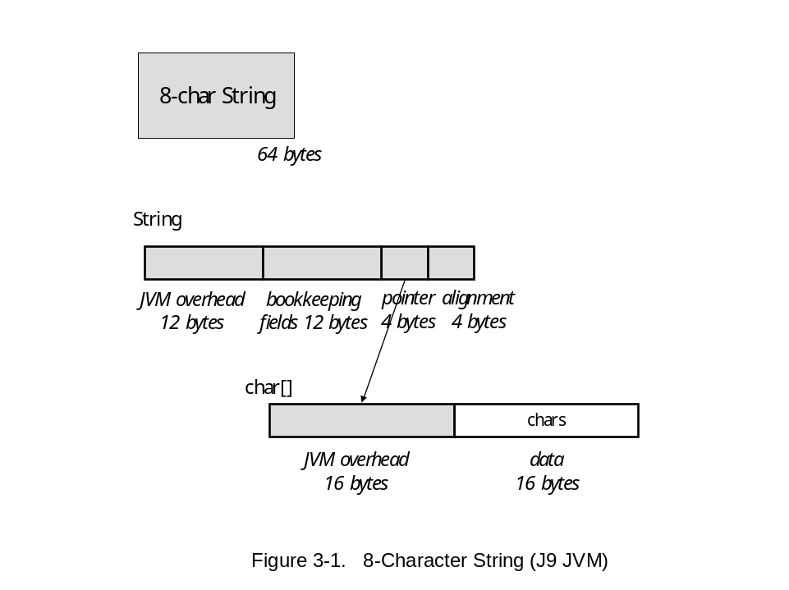
<Figure>
To understand why there is so much overhead, it is useful to dig deeper into its different sources.
- Object overhead is overhead imposed by the JVM. Each object has a header that the JVM needs to manage storage allocation and garbage collection.
- Pointers are the glue of data structures, and are a main source of overhead.
- Bookkeeping fields are numeric and Boolean values, which cannot be counted as data, since they store information about the representation, not real application data.
- Alignment overhead ensures that primitive data starts at proper byte and word boundaries.

A Java string is actually two objects: a String object and a char array object, so there are two object headers in every string. Additionally, there is a pointer to connect the String object and the char array. The String object also includes several bookkeeping fields, such as the length of the string. Finally, the String object needs 4 bytes of alignment. The String object itself is entirely overhead, containing no real data. Adding all of this overhead together, the cost is 48 bytes, which is 75% of the total 8-character string. The numbers are not that much smaller for SUN JVMs - in fact, the cost of strings on every JVM falls in this range.
If you were to design a string representation from scratch, 20% overhead might seem reasonable. For a string in Java to have only 20% overhead, it would have to be 96 characters long. The fixed cost overhead of a string is amortized as the string gets longer. However, it is not always possible to amortize overhead costs, as discussed in Section 3.4.
Strings, of course, are pervasive in almost all programs, so proper management of strings is critical for memory health. This is a big topic that will come up again later.
3.2 Data Structure Cost Notation

At this point, it is useful to have a diagram notation to illustrate more complex examples, as a way of talking about a data structure and how it is using memory. Figure 3-2 shows the basic elements of a content schematic. A content schematic summarizes the cost breakdown of a data structure.
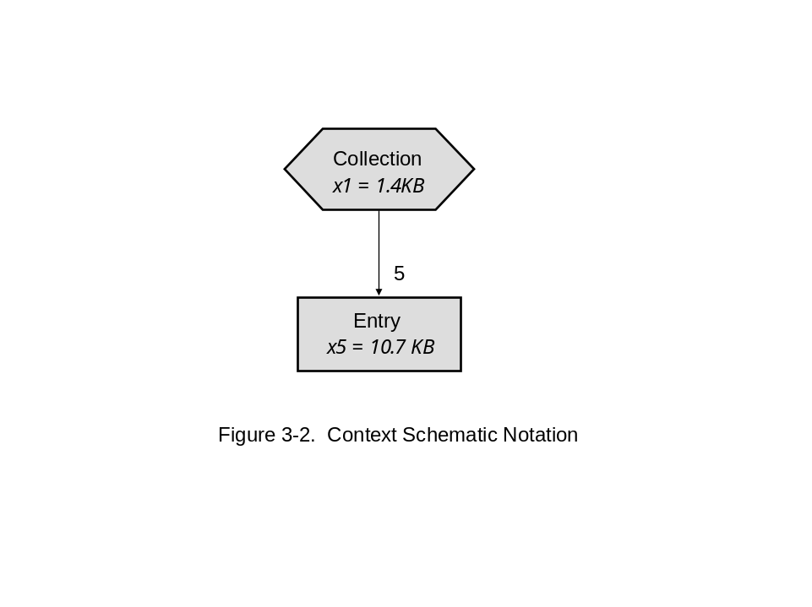
There are two types of boxes, or entities, in a content schematic. Hexagonal boxes are collections, and rectangles represent all other entities. Rectangle entities are typically entries or elements of collections. An edge in a content schematic is labeled with the average fanout from the source entity to the target entity. In Figure 3-2, there are on average 5 elements, named Entry, contained in each Collection.
Entities in a content schematic are abstracted from the actual data structure objects. A box may be hiding other objects that help implement the entity. For example, an entity might be named String, and as you have seen, a string consists of more than one object. A String entity would represent both the String object and the char array referenced by it. The memory cost of an entity is the sum over all of its objects. Summarizing a set of related objects as an entity removes clutter and helps understand overall costs.
The notation xN inside each entity means there are N instances of the entity. The expression xN = M KB means that there are N instances consuming M KB of memory. In Figure 3-2, one Collection consumes 1.4 KB, and the five Entrys consume 10.7 KB.
Content schematics are a little like UML diagrams, since they represent a schematic of entities and relationships. Unlike UML diagrams, relationships are elevated to be entities, rather than edges. The reason is that in a language like Java, implementation of the relationship itself is often a big cause of expense, so it is important to make that visible. A very common pattern is to implement relationships as collections.
Figure 3-3 shows a relationship between Strings and Integers, which is implemented by a HashMap collection. Since the overhead for a string is 48 bytes, as shown in Figure 3-2, it is possible to compute the bloat factor and estimate the average length of the strings in this map. Five strings consume 240 bytes of overhead, which leaves ?? bytes to store characters. So the bloat factor is ?? and the average length is ??.
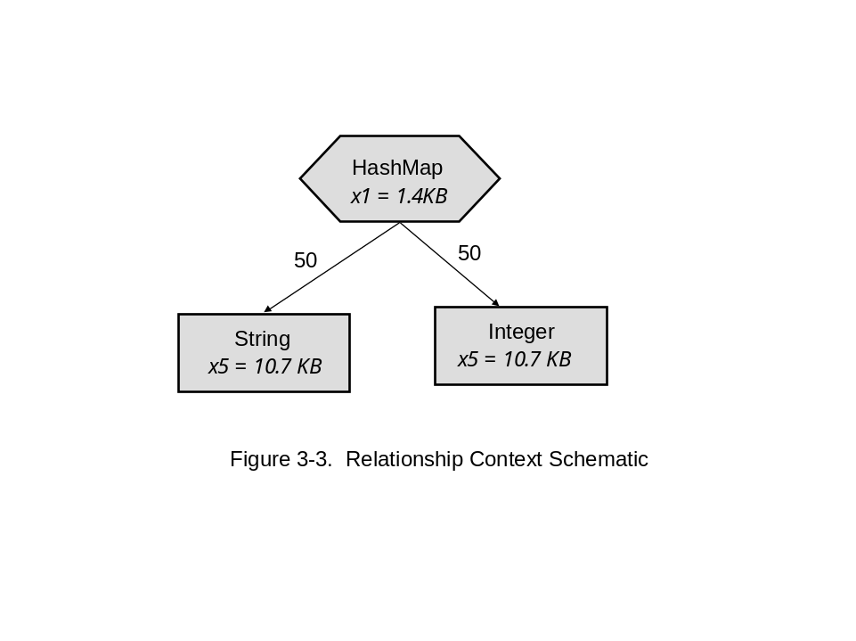

Sometimes it is necessary to drill inside an entity and examine the objects that make up an entity. (Show type graph of String???)

3.3 Example: Sorted Map of Doubles

Consider the following problem: design a program to read in a map of doubles to double and store the map in sorted order by key. After loading this map of doubles to doubles, a second phase of the program will use it. The details of this second phase are not important here. This is an example of a very common more general pattern:
Load-and-Use Behavior Pattern: load data in one phase, use the data in the next phase.
A main design issue for this example is choosing a data structure for the map. A regular HashMap is not a good choice, since it is not possible to keep the entries sorted in the HashMap. Three possible choices are described.
Solution 1. Fortunately, the Java standard collection library has a TreeMap class that maintains its entries in sorted order, so this appears to be a perfect choice. The only problem is memory health.
A content schematic TreeMap from Doubles to Doubles with 100 entries is shown in Figure 3-4. This is a fairly simple example, since Double is just a single class. There are more complicated examples later on, where three or more classes buried inside one of these entry boxes. The total cost of this data structure is 8.6KB. While this is a small example with only 100 entries, it is reasonable to ask whether this is a healthy data structure. Is this 8.6KB well spent? It is not hard to compute the health here, since the actual data needed to represent a double is eight bytes, so 200 doubles consumes 1.6 KB of actual data. Therefore, 7KB of this structure, or 82%, is overhead. This is not very healthy.
Looking at the health of each entity can provide some insight. The doubles are stored as Double objects, since scalars must be boxed before storing them in a standard Java collection. A single instance of a Double object is 24 bytes. Since the data for a double is only 8 bytes, a Double object consists of 33% actual data, and 67% overhead. This is a high price for a basic data type, but this is the usual, expected cost of doing business in Java.
Popping up a level, the TreeMap consumes 3.9KB. This number is surprisingly high, so what is taking up the space in there? A TreeMap, like every other collection in Java, has some kind of wrapper object, the TreeMap object itself, and, in this case, it points to 100 TreeMap$Entry objects. Each type of collection in the standard library has a different kind of infrastructure, some point to arrays, some point to separate entry objects. In this case for TreeMap, there is a TreeMap object, and for each entry, there is a Treemap$Entry object. This is very typical of collections. They typically have a fixed overhead, in this case it is 48 bytes, and then they have a per-entry overhead cost, in this case it is 40 bytes per entry. These 40 bytes are made up of JVM overhead, five pointer fields, and maybe a Boolean also. This relatively high per-entry cost makes TreeMap is a particularly expensive collection. The costs of other collections are given in Chapter 7.
The use of a TreeMap is not necessarily a wrong design. It depends on whether that 82% overhead is buying something useful. In this case, the main thing it is buying is the ability of TreeMap to maintain a sorted order while you are randomly inserting and deleting elements. It is constantly maintaining a sorted order. If you need something to be in sorted order during the load phase, or maybe you have a real time monitor that is constantly being updated, and you need to look at it in that order, then TreeMap is a great data structure. But if you do not need this functionality, there are other data structures that could accomplish the same thing. In fact, in this example, the sorted order is only needed for the second phase after all the data is loaded. The Load-and-Use behavior pattern can be exploited to choose a cheaper representation.
Of course, the other nice thing about TreeMap is that it can be pulled off the shelf. But maybe there are other collection classes that can be pulled off the shelf, or maybe there are other kinds of collection classes that can be put together. This does not mean that programmers should be writing their own collections, but there are some cases where you can slap a thin wrapper over something that already exists.

Solution 2. A less expensive alternative is to store the double to double map as an ArrayList of pairs. Since sorted order of elements is not needed until the map is loaded, the ArrayList can be sorted once, after the first load phase. There is a bit more programming required to implement this solution, but it is not excessive. Fortunately, the Java standard Collections class has some useful static methods, namely, a sort method and a binarySearch method. Each of these can take a Collection and a Comparator as parameters. This design requires two new classes:

public class Pair {
double first, second;
public Pair(double d1, double d2) {
first = d1;
second = d2;
}

double getFirstDouble() {
return first;
}
double getSecondDouble() {
return second;
}
}

public class PairComparator implements java.util.Comparator {
public int compare(Object o1, Object o2) {
d1 = ((Pair) o).getFirstDouble();
d2 = ((Pair) o).getSecondDouble();
if (d1 < d2) return -1;
if (d1 == d2) return 0;
return 1;
}
}

Additionally, there needs to be a wrapper class, to implement map functions. This can either implement the Java Map interface, or some similar interface. Here is a skeleton showing the get method for this wrapper class:

class DoubleMap extends java.util.Map {
private ArrayList ar = new ArrayList(); static PairComparator comparator = new PairComparator();
…..
Object get(Object key) {
int result = Collections.binarySearch(ar, comparator);
if (result < 0) return null;
return ar.get(result);
}
}

The content schematic for 100 entries is shown in Figure 3-5.
< put in example >
Solution 3. This solution has almost no extra overhead, and is at the other end of the spectrum from the first solution. It uses two parallel arrays of doubles. One array stores all of the keys, and the second stores all of the values. You can put an object façade on top of this object is desirable to provide an object facade.
This is an extreme choice that breaks the Java object model, and should only be used in situations where memory is very limited. The other downside of this design is that you have to write a bit more code to implement it, but it is not terrible. The Java Arrays class has sort and binarySearch methods that can be pulled off the shelf. However, these methods apply to a single array. If you sort the keys, you lose the association with their corresponding values. You can use an extra temporary array to get around this problem. The solution is left as an exercise.
The context schematic for two arrays of 100 doubles is shown in Figure 3-6. The overhead consists of two object headers, which is 2% of the total structure (probably more with the wrapper -- add). This design is as good as you can get space-wise for this problem.

3.4 Scalability

The solutions in Section 3.3 deal with a relatively small amount of data. There are only 100 entries in the map. Maybe if solution is scaled up, the high cost of the first TreeMap solution will be amortized away, and you be just fine. Suppose the TreeMap has 10,000 entries. Unfortunately, a 10,000 entry TreeMap is still at 82% overhead. The reasoning here is that the overhead costs here are per entry costs, and they are high. So whenever you add an entry, this adds two Doubles, with all their boxing costs, and a 40 byte TreeMap$Entry object. It costs 88 bytes per element, and only 18% of that is actual data. So in effect, this design is not only bloated, but it also does not scale. It is constantly bloated.
Look at the scalability of this. Basically we can use this health idea to gauge scalability as well; which parts of our design are scalable and which parts aren’t scalable. So if we just grab our treemap, we see that for a much smaller number, it was actually 88% overhead, it was even higher overhead, and very quickly the fixed cost of the treemap, that gets amortized away very, very quickly, and then it’s a constant per entry overhead after that. With our alternative design here, 2 double arrays, it goes down to 0% overhead very very quickly; basically just the header costs of the arrays. You really are just paying for pure data here

3.5 Summary

Just a quick summary of the health idea here. We have a lot more formal health work available, for this course, just
There are lots of ways you can chop up the health, there are all different kinds of overhead; you can think how much overhead is empty array slots; how much overhead is due to certain classes of pointer costs; and we’ll see some cases of that. But the main point here is just a way of thinking -- how much of my design is the real stuff, and how much is the artifacts of the way I represented it; because those will show how much room for improvement there is. And if in fact you pay pay a reasonable price for what you are getting for it.
We don’t want developers optimizing things that aren’t problems, but can’t just close your eyes and say everything is going to be fine.
We need tools to predict sizes across the layers, much better automated optimization
I’m not saying throw out all the java libraries and write everything yourself at all, I’m just saying as a thought experiment, use a limit – this is how good you could get this design; it requires more work, possibly more debugging, but you have to weigh. We did a case recently where this turned out to be a good design, because they had such scalability problems using a treemap.

